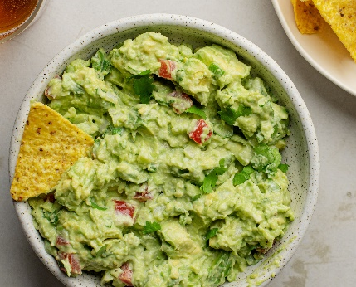

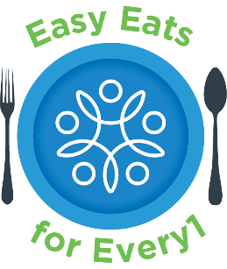
t°°q
Step 2: Avocado
Cut avocado in half and remove the pit. Spoon the flesh of the avocado out and put it into a mixing bowl.
Use a fork to mash the avocados.
Spatula
Mixing bowl
Knife
Cutting Board
Fork
Spoon

Utensils
Ingredients
4 ripe avocados
2 tomatoes
1 red onion
1 Tbsp minced garlic
Lime juice
Salt and pepper
Optional: cilantro
Scan this QR code with your phone to view an our Easy Eats for Every1 YouTube Channel!
Guacamole
Step 5: Dippers
Grab your favorite dippers!
Some examples:
Carrots, cucumbers, broccoli, ritz crackers, saltines, tortilla chips, etc.
Step 6: Enjoy!
Serve and enjoy!!
Step 4: Season
Add
Add lime juice and salt and pepper to taste. Mix all ingredients together.
Step 3: Mix
Add diced tomatoes, onion, and minced garlic to the bowl with mashed avocado and stir to combine.
Step 1: Prep Veggies
Dice red onion and tomatoes.
Mince garlic.
Kitchen Safety Tips:
Use a cutting glove if available to protect yourself.
If you are uncomfortable using a knife, ask someone for help.
Recipe Instructions

