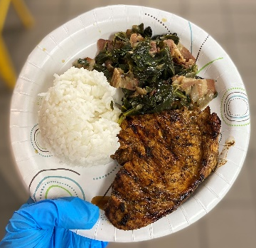

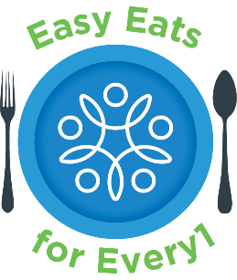
t°°q
1 bunch collard greens
3 slices bacon, chopped
½ onion, diced
2 cloved minced garlic
1 tsp salt
½ tsp pepper
½ cup broth of choice
Olive Oil
Step 4: Season
Add
Add salt and pepper. Stir to combine.
Add in broth and greens. Stir to combine. Put lid on the pan.
They may not all fit in the pan at once, wait until they wilt which will free up some space in your pan.
Utensils
Cutting board
Knife
Measuring cups and spoons
Deep frying pan with lid
Tongs
Spatula
Ingredients
Collard Greens
Step 3: Sauté
Heat oil in frying pan over medium high heat. Add bacon and cook about halfway through. Add diced onion and minced garlic, continue to sauté until onion is tender and everything is fragrant.
Step 1: Prep Greens
Soak your collard greens in cold water for about an hour.
Scrub them clean.
Remove the leaves from the stems. We will only need the leaves, and not the stems.

Step 2: Prep
Prep your cutting station by laying a damp cloth down and placing your cutting board on top.
Rough chop collard greens, dice onion, mince garlic, chop bacon.
Make sure you do the bacon last to avoid cross contamination!

Step 5: Cook
Continue to add greens and cook them until all have wilted, become tender, and turn a dark green.
Step 6: Enjoy!
Serve with your favorite meal and Enjoy!
This can be stored in an airtight container in the refrigerator for about 3 days.
Scan this QR code with your phone to view our Easy Eats for Every1 YouTube Channel!
Kitchen Safety Tips:
Always use a pot holder!
Let anyone in your home know you will be using the stove.
Recipe Instructions

