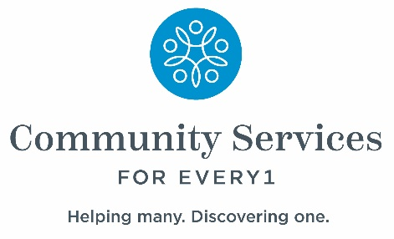
West Seneca Campus Trip Request/Referral Form
Please email to wscampustrips@csevery1.com
For additional assistance/questions or to request an alternate way to submit a request form, please contact the Program Manager Marcus Harris at: 716-896-2180 ext. 330

- Name of person(s) needing transportation services:
_____________________________________________________________________________________
- Pick up/drop off address (must be within Erie or Niagara counties):
_____________________________________________________________________________________
_____________________________________________________________________________________
- Email and phone number (please indicate which is preferred for notification of trip approval):

______________________________________________________________________________

______________________________________________________________________________
- Purpose of Trip (all trips must be for meetings or events held by OPWDD):
_____________________________________________________________________________________
_____________________________________________________________________________________
_____________________________________________________________________________________
- Date trip is needed: _____________________________

- Requested pick up time (from home to campus): ____________________________________

- Requested pick up time (from campus to home): ____________________________________

